**CAB201 Programming Principles - Semester 2, 2019**

**Report for Assignment: Project – Genomic Sequence Retrieval - Part II**

**Student name and number: Nicholas Havilah N10469231**

**Build and Run Instructions**

Please provide clear step-by-step instructions here on how to build your program in Visual Studio and run your program in the command line, given your submitted zip folder. For each step, you should include a screenshot. You may expand the box if needed.

*[Enter build & run instructions. Include where to find .sln file (with screenshot), how to build your program (with screenshots), how to find the .exe file (with screenshots), and finally a screenshot of your .exe program being run from the command line]*

1. *Open the .sln file in Visual Studio(this can be found when the .zip is extracted and the folder is opened.*

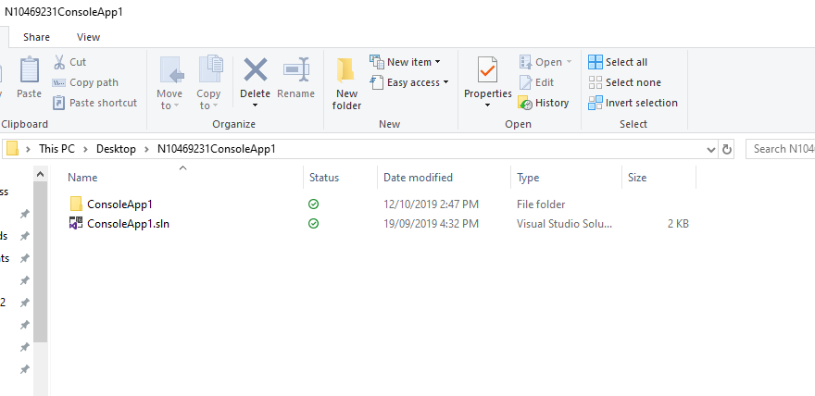

1. *Press Ctrl+Shift+B or select Build and then Build Solution*

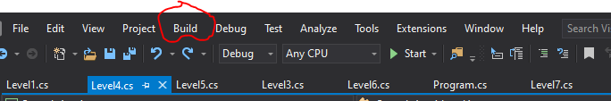

1. *Open the command line and cd into the working directory where the .exe is located (location of entire ConsoleApp1 project/ConsoleApp1/bin/Debug*



1. *To run a specific level, type in the relevant commands as per the assignment specification sheet. (e.g. ConsoleApp1 -level5 16S.fasta CTGGTACGGTCAACTTGCTCTAAG)*

*For Level 4:*

1. *Open the folder labelled IndexSequence16S*. *Run the .sln file as per steps 2 & 3 from above. (the directory will now be the IndexSequence16S instead.*
2. *Run the first instruction “*IndexSequence16s 16S.fasta 16S.index”.
3. *From the Debug folder, take the 16S.index file and place it in the ConsoleApp1 Debug folder*
4. 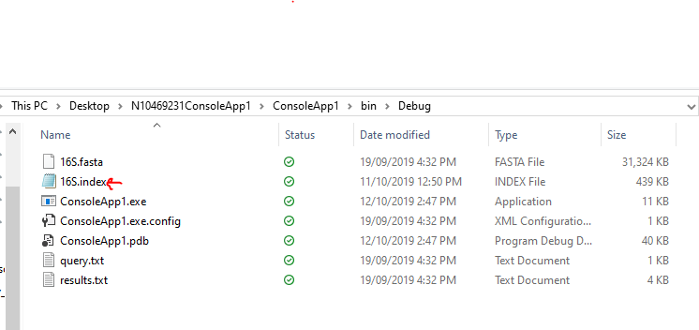

**Statement of Completeness**

This statement of completeness will need to *accurately* state the functionality which has been implemented. There will be a penalty of 3.5 marks (loss of 3.5 marks) for a non-completed or submitted statement of completeness, and a penalty of 1 mark for each inaccurate statement to a maximum of 3 marks.

**In the following section, you are required to mark which functionality you have implemented. In the column on the right please mark ‘Y’ where you have completed this functionality, and ‘N’ where you have not. Please fill in any additional text boxes requested, and please note any limitations or bugs in the box at the end of each section. You may expand the table if you need more room for comments.**

|  |  |  |
| --- | --- | --- |
| **Basic Functionality** | | |
| **Build & Run** | When following the Build & Run instructions, the program successfully builds and runs. This was tested in a QUT SEF lab with a new login session, using the same zipped folder that is submitted. | **Y**/N |
| **Basic itinerary output** | The program displays the data from the file | **Y**/N |
| The program displays the appropriate line | **Y**/N |
| The correct amount of information is displayed, e.g. only the relevant entries | **Y**/N |
| The correct level, provided as a command line flag ***-levelN***, is executed | **Y**/N |
| The program **does not** store the whole file in memory, instead it accesses the file on disk | **Y**/N |
| **Error handling** | A clear error message is displayed when an incorrect number of arguments is provided | **Y**/N |
| A clear error message is provided when an incorrect flag is provided (e.g. not -level1, etc.) | **Y**/N |
| A clear error message is provided when the input file doesn’t exist, or is incorrectly formatted | **Y**/N |
| **Comments** |  | |

|  |  |
| --- | --- |
| **Searching Algorithm – Part II**  Please underline, circle or highlight the levels that were completed. | |
| **Algorithm** | **Level:**  Level 4, **level 5, level 6, level 7** |
| **Bonus:**  Sequence matching using wildcards  *If completed, please highlight level 7 above and discuss how you approached the problem and why you solved it the way you did.*  ***Level 7 was approached in a similar way to level 2. Instead of using a sequence ID as input, a regex pattern was used instead(Match = Regex.Match(currentLine,regexPattern); then an if statement was used to check if the bool returned true. If it did then the pattern was printed to the console.*** |
| **Level 7 Explanation**  *If you have completed the optional level 7, please include details on how you solved it and any resources you may have used.*  *Resources used: level 2 and regexone.com* |
| **Comments** | *Please note any limitations, bugs, logical errors, differences from provided examples and possible explanations, and/or run-time errors here* |

**Screenshots of Functionality**

**In the following section, you are required to provide screenshots that provide evidence of your program working with provided input. You must complete this section.**

1. The 16S.fasta file has been provided with this template. Download them and place them in the same folder as your .exe file. You may have extra files, e.g. a query file, in this folder, and your .exe may be named differently. This is fine.
2. Open the command prompt and go to the above folder. In the command line, type the name of the .exe file and copy and paste following arguments:

Search16s -level4 16S.fasta 16S.index query.txt results.txt

|  |
| --- |
| **Place screenshot of entered command line arguments here:**  **Level 4:**    **Level 5:**    **Level 6:**    **Level 7:** |

1. Hit enter to run your program.

|  |
| --- |
| **Place screenshot(s) of the full output to console of your program. You may expand the box as necessary, and use as many screenshots as needed:**  Level 4:    Level 5:(the sequence id does not exist in the fasta file)    Level 6: |

Level 7:

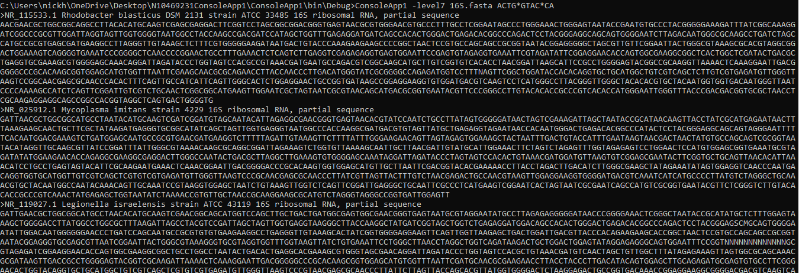

**Self-Assessment:**

1) How do I think I went with this assignment?

**Insert Answer Here**

So far, I have made good progress on the assignment, achieving small parts every week to ensure productivity. Plus, I implemented classes at the start of the development process which made things easier for modularity.

2) What did I find difficult in this assignment?

3) What would I do differently next time?

**Insert Answer Here**

Understanding level 4 was difficult. The way the level requirements were written made it difficult to understand without seeking outside assistance to understand the requirements of the tasks.

**Insert Answer Here**

This process worked much smoother than part one so I wouldn’t change how I approached the assignment.

4) Were there any bugs in my assignment, if so what were they?

Currently level 4 does not output to the text file correctly, as it doesn’t print a new line for some of the sequences(though the sequences are the correct ones). Level 4 is also the only level without error handling.

**CRA:**

Please fill out the following CRA, reporting how many marks you believe your project might be awarded. Your assessment should be a considered reflection on what you have achieved. The purpose of this is to advise the marker of what you believe was achieved in order for us to pay attention to discrepancies. **Your self-assessment is NOT attracting marks, but must be provided (penalty applies if missing)**.

|  |  |
| --- | --- |
| **Code Quality**  To score points in this section, the student must follow the code quality guidelines as specified in the C# Coding Style Guide on Blackboard | **/30** |
| Maintained consistent, clear, and meaningful standard in variable and method naming. No magic numbers. | /3 |
| Well structured – consistent and appropriate white spacing, line length, indentation, and separation into files within the project (i.e. one class per file) | /2 |
| Well commented – class header comment at beginning of each class, comment before every method, and in-line comments to explain complex or not easily discernible code. In-line comments are not excessive. | /4 |
| The DRY principle (Don’t repeat yourself) is followed where appropriate | /3 |
| Methods are single purpose and clear | /4 |
| Classes are well designed, with high cohesion and low coupling | /8 |
| Classes are separated into reusable modules where appropriate | /3 |
| Exceptions are thrown and handled appropriately | /3 |

|  |  |  |
| --- | --- | --- |
| Basic Functionality  To score marks in this section, your program must be able to be run from the command line with the appropriate arguments. | | **/15** |
| *Basic Output* | The program displays the data from the file | /1 |
| The program displays the appropriate line | /1 |
| The correct amount of information is displayed, e.g. only the relevant entries | /1 |
| The correct level, provided as a command line flag ***-levelN***, is executed | /1 |
| The program **does not** store the whole file in memory, instead it accesses the file on disk | /5 |
| **Total:** | **/9** |
| *Error Handling* | A clear error message is displayed when an incorrect number of arguments is provided | /2 |
| A clear error message is provided when an incorrect flag is provided (e.g. not -level1, etc.) | /2 |
| A clear error message is provided when the input file doesn’t exist, or is incorrectly formatted | /2 |
| **Total:** | **/6** |

|  |  |  |
| --- | --- | --- |
| Part II  To score marks in this section, your program must be able to run levels 4-7. | | Marks Available: |
| /55 |
| *Level 4* | The program creates a file as specified by the command line arguments | /2 |
| The index file contains a list of all the sequence ids with the appropriate byte-offset | /5 |
| The searching program makes use of the created index file to execute a number of queries | /5 |
| A clear error message is provided when the index file does not exist | /1 |
| Clear error messages are provided when the query file cannot be found, or when a bad query is given, like in Level 3 | /2 |
| **Total:** | **/15** |
| *Level 5* | The program correctly locates and prints the requested sequence ids | /10 |
| A clear error message is provided when the sequence does not exist | /5 |
| **Total:** | **/15** |
| *Level 6* | The program correctly locates and prints the requested sequence ids | /15 |
| A clear error message is provided when the keyword does not exist | /5 |
| **Total:** | **/20** |
| *Level 7 (Optional)* | The program correctly decodes the expression given and identifies any matching sequences | /5 |
| A clear error message is provided when the sequence does not exist | /5 |
| **Total:** | **/+10** |